1. 
2. We are not only interested in algo running in less time but also consuming less memory even though memory is very cheap nowadays.  
   Such as mobile app must consume less amount of memory as in mobile app we’re much concerned about memory as only one user is going to use an app not millions of users on a single mobile.
3. Again we will use Big O notation to describe how much space an algo requires.
4. 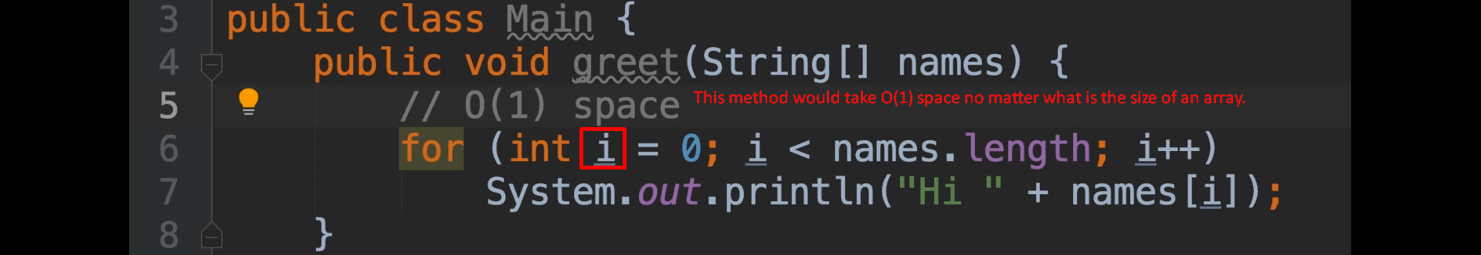
5. 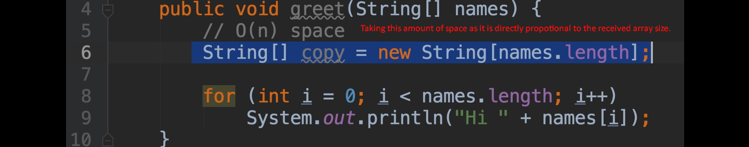
6. 